The Cost of College Tuition is on the rise!
And so are coaches’ salaries

As you read this please understand that I am not against a good college education. Nor, am I against college sports (given the choice of college football or the NFL, I will choose college football every time). I’m certainly not against making a lot of money! I’m not even against rising tuition costs of colleges and universities if the costs are rising for the proper reasons. However, I have questions about whether we have it right in America or not.

Since I have cousins who attended the University of Alabama … this is the college I will pick on today.

In 2008 the tuition cost for in-state students was $6,400 per year at the University of Alabama - Tuscaloosa. The cost for out-of-state students was $15,294 per year at the same school.

In 2017, 10 years later the cost for in-state students had risen to $10,780 while the cost for out-of-state student’s tuition and fees was up to $28,100 … and this does not include “Room and Board.”

This is an increase of 5.35% per year for in-state students (compounded annually) and an increase of 6.27% per year (compounded annually) for out-of-state students. Don’t ask me why the cost went up a greater percentage rate of out-of-state students then for in-state students because I don’t have a clue.

If we go back 20 years, to 1998, this is what we find:

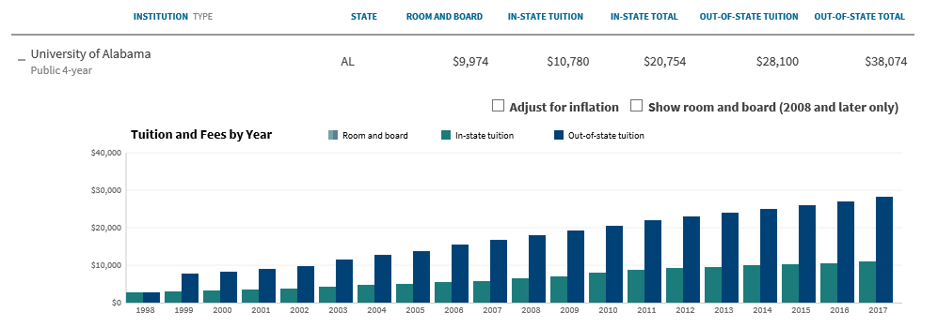

You should be able to click on the graphic to go to the web page. You can search on University of Alabama and then click on the first college that comes up and you will get the above graphic.

Notice the cost of in-state and out-of-state was listed the same ($2,684 per year in 1998) and again it does not account for room and board. Based on these results in-state has increased by an average of 7.20% per year while out-of-state tuition has increased by 12.46% per year. Why is this important? Because, in my analysis later I will be using an inflation rate on college cost of just 7% per year and I want you to understand why.

Source: https://www.chronicle.com/interactives/tuition-and-fees

In the meantime, here’s a question … Has the actual education gotten that much better in the past 10 years – or even in the past 20? I mean after all the cumulative cost of inflation from 2008 through today has been 17% based on this US Inflation calculator www.usinflationcalculator.com, which is an annualized increase of 1.58% per year (compounded annually) while the current average annual inflation rate stands at 2.9% per year dating back to 1913.

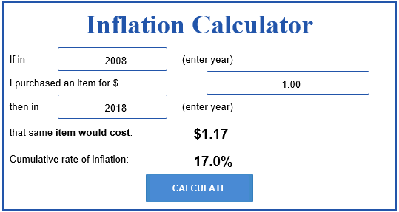

If we go back to 1998 the cumulative rate of inflation stood at 54.6% which is a compounded rate of 2.22% per year.

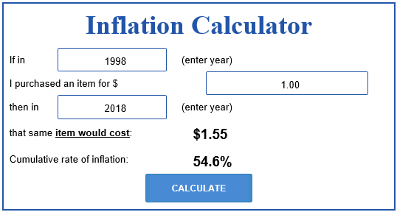

Unfortunately, the cost of education (and many other costs) are not calculated into the Consumer Price Index (CPI) put out by the U.S. Government. Someday I may write an article about what is in the CPI … but for now I’m focused on education and the rapidly increasing cost.

I wonder … could a part of the drastically increasing costs be for reasons such as the one that follows?

Nick Saban, Alabama’s head football coach, signed a new 8-year contract (2018-2025) on Friday 7/27/18 that will pay him $8.3 million in 2018, increasing to $10.3 million in 2025. Saban will be 73 years old at the start of the 2025 season (source: Sports Illustrated).
To hear the college tell it, it would go something like this; “Nick Saban’s salary and other athletic costs are paid from ticket sales and the money that athletics brings into the college.” That may me partially true, but I would suspect that some of the cost must come from the general fund of the University – at least in some years.

In 2017 Alabama Athletics brought in $174.3 million. The school made $15.6 million more than it spent in 2017 – but that profit was down $3.1 million from the previous years profit of $18.7 million, while revenues were up in 2017 by about $10 million.

NOTE: Nick Saban alone is getting 52.21% of the school’s net profits.

In terms of just football the profit was $45.9 million in 2017 with total revenue of $108.2 million. However, football profits were down $1.8 million from 2016 to 2017 while revenue was up from $103.9 million to $108.2 million. In 2017, TV Contracts and other rights brought in $43.9 million while contributions from the public and alumni counted for $32.9 million. These contributions from the public and Alumni could take a big hit in 2018 with the tax plan passed by congress and signed by the president. In the past 80% of those contributions could be written off as charity donations. That deduction is eliminated under the new tax plan.

Note: Nick Saban is getting a total of 18.08% of the total football profits.

Source: https://www.al.com/alabamafootball/index.ssf/2018/01/alabama_athletics_brought_in_1.html

I guess and argument could be made that without Alabama Football with profits of $45.9 Million – the University of Alabama would actually be operating in the red by about $30 million or so … thus, it is worth it to have football at the University. That is a good argument – but I still think that paying the head football coach 18% of football profits and over 50% of total school profits is a lot to pay to have a football team – though it is a winning team.

Now the question is … can we believe the Sports Illustrated Article. According to USA today (Link here) in 2017 Nick was paid $11,132,000. Of the 130 NCAA coaches ranked … 78 made in excess of $1,000,000 that year and 43 made in the high six figures. You can see the chart by clicking on the above link.

So, are high salaries bad?

Don’t get me wrong, I’m not against high salaries. Most American Corporations pay the CEO extremely lucrative salaries PLUS more when you consider the stock options and other bonuses. A head coach to a major university football program is a lot like a corporate CEO.

According to a report from the Economic Policy Institute, the average CEO pay is 271 times the nearly $58,000 annual average pay of the typical American worker. Let’s see … that would be about $15,718,000 per year.

While it would be good to be on the receiving end of the $15,000,000 per year in Corporate America – or even $8,000,000 per year in college football – I have to wonder if one human being is really worth that much money year in and year out.

Perhaps they are and perhaps they are not. It all depends on how you look at it personally.

Some of the most valuable people in the world might be medical surgeons. After all, these men and women save lives … yet they earn between $240,000 and $736,000 per year with the average being around $516,000. Far less than a football coach that provides good entertainment or a corporate CEO that provides (hopefully) a good investment return for the company and the shareholders. A Google search tells me the average annual income of a firefighter is only $45,420 while the average pay of a police officer is $61,270 – and these are our first responders during troubled times. On average a US Soldier earns $33,624 (naturally commissioned officers earn more and low-ranking enlisted personnel earn less) and these are the individuals willing to risk life and limb so that we can have freedom to choose our education and religion in this country.

What makes them or doctors worth less than CEOs or Football coaches?

Source: https://www.nursetheory.com/heart-surgeon-salary/

Let’s not forget the college professors who teach academics to these young athletes and others in the college or university. During the years 2013-2014 the average pay for a college professor in America was about $126,981 while instructors (those without PhD’s) earned about $50,032.

Source: https://www.washingtonpost.com/news/on-leadership/wp/2014/04/07/heres-what-the-average-full-time-professor-made-last-year/?utm_term=.275645dc8957

Now if the average athlete is going to get more out his/her academic studies in terms of a paycheck, shouldn’t the people teaching the academics be paid more than those teaching them to run and catch a football? Let’s face it, of all NCAA athletes in colleges at graduation time only 9.5% end up in professional baseball. 1.2% end up in professional basketball for men (and 0.90% for women), 1.6% end up in professional football, 6.4% end up in professional ice hockey and 1.4% end up in professional soccer.

So, if 90 to 98% of all those who graduate are going to end up not playing professional sports … why would the college coaches be paid so darn much more money than the professors and instructors that teach these students what they need to know to graduate and become a productive member of society?

As of April 2018, there were 73,063 NCAA College Football Players. Approximately 16,236 were eligible for the NFL draft and only 253 were drafted. Odds are very high against becoming a professional football player upon graduation from college, and it’s more than likely that the person graduating as a college football player will simply have to get a job since only 1.6% will ever play in the NFL.

Remember that 9.5% of college baseball players end up playing professional baseball whereas only 1.6% of college football players end up playing professional football. Yet, the average earned by a college baseball head coach is $57,500 based on a survey by CUPAHR: Source https://work.chron.com/much-money-college-coaches-make-7750.html

Compare that with the USA Today article that states the average football coach in the NCAA earned 1.64 Million Dollars (in 2012).

Source: http://www.ncaa.org/about/resources/research/estimated-probability-competing-professional-athletics

Now my article is not the first article that raises this issue. In the 39th Volume of “Public Opinion” written in 1905 about Harvard’s head football coach, Bill Reid we find this short article:

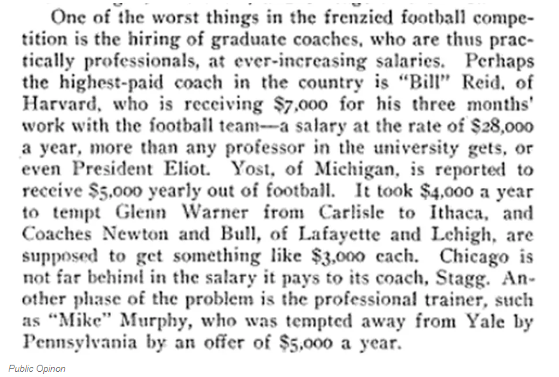

A $7,000 salary in 1905 dollars (assuming an annual inflation rate of just 2.9% per year would be equal to $177,025 today … so again, coach’s salaries have grown a heck of a lot more than the rate of inflation.

College costs continue skyward … for how long?

So, why are the Colleges and Universities paying the coaching staff so much more than they are paying the ones responsible for training our future generations for the workforce and professional occupations (other than sports) today? It is a question that I don’t have the answer for.

However, as a veteran of the financial services industry with 42 years of experience I do know this … the cost of college is not coming down anytime in the near future. Regardless of what some political pundits want (e.g. “free education” for everyone – which has a snow-ball’s chance in hell of becoming a reality).

To see how much tuition has increased just in the last 20 years, on average, take a look at the chart that follows:

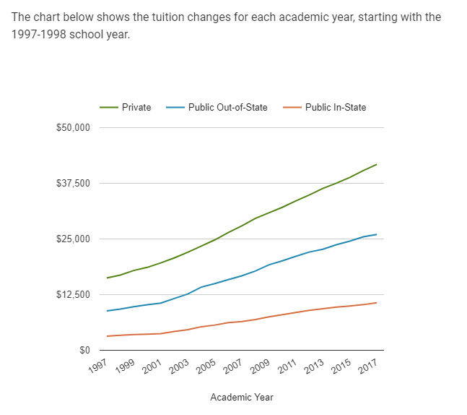
US News and World Report 1

In the late 70s though, tuition costs began to rise and have continued to do so steadily every year through today. Here is a short comparison for a four-year degree in 1980 and 2013 in three categories:

- Tuition at a Public Institution – 1980 – $2,550 and in 2013 – $7,196
- Tuition at a Private Institution – 1980 – $5,594 and in 2013 – $15,786
- Average Total Tuition Amount – 1980 – $3,449 and in 2013 – $9,733

In the last decade, the situation has not improved. The rising cost of higher education has greatly surpassed the general cost of living expenses and medical expenses. While the U.S Government has made it easier for anyone to attend college with the various student loan programs currently available, they have also helped fuel the rising cost of higher education by lending too easily. That degree that was once sought after and had a great impact on someone’s financial life, is now less valuable due to such a high number of college graduates, yet more expensive to attain.

Source: https://www.studentdebtrelief.us/news/rising-tuition-costs-and-the-history-of-student-loans/

I told you earlier in this article that College costs have far exceeded the cost of all items in the Consumer Price Index (CPI). Study this chart for proof:

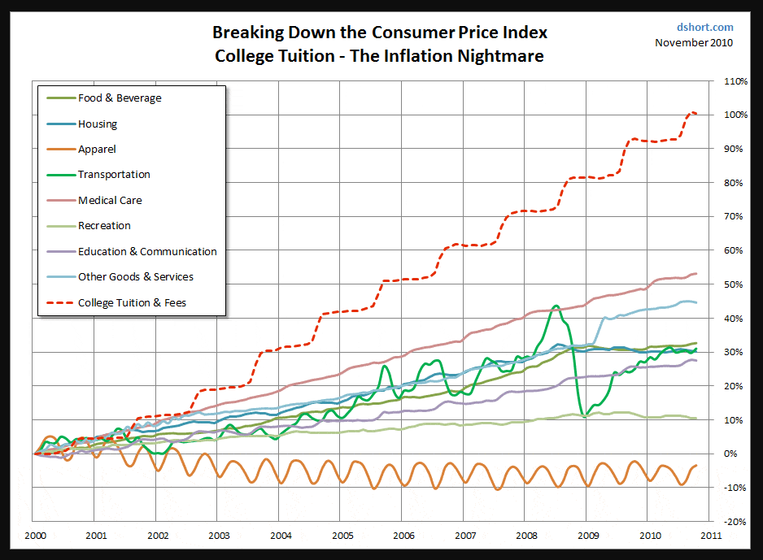

Now why the is this, and does it really make sense? In manufacturing … the greater the quantity of items (“widgets” if you will), the lower the cost to manufacture the “widget.” Aren’t colleges simply manufacturing college graduates?

In 1940 the number of college graduates totaled 186,500 in America. By 1950 that number had more than tripled to 432,058. By 1970 those receiving bachelor’s degrees totaled 839,730. By the end of 2016 this number of people earning their first undergraduate degree in America increased to 2,246,233 for the year.

So, again, why does it cost more to produce more smart humans when in normal manufacturing the more quantity produced the less the cost? I could understand a nominal increase of 2% or so per year to keep pace with inflation … but why is the cost so much greater? Is it truly because the government is making it easier for anyone to attend college by making loans so readily available – or is it because some colleges tend to spend money on needless items to entice more students to come to their institution?

The one thing I know for sure in a capitalistic society that I am so proud to live in is that anyone selling anything can “charge what the market will bear.” In business, this is known as “pragmatic pricing.” It means you charge based on what the customer will spend and not based on what it cost to manufacture the product. Therefore, if we Americans are willing to pay exorbitant cost to educate our child … the college or university will certainly be happy to charge ever higher costs.

The cost to attend Yale University in 1940 would have been $900. On an inflation adjusted basis that would have been $15,197 in 2015 dollars. However, the tuition cost at Yale University in 2015-2016 was actually $62,200. The actual cost increased over 4 times greater (that’s 400% more folks) than what it should have been when accounting for the cost of inflation. Over the 76-year period shown the cost of one year at this school increased 69.11 times.

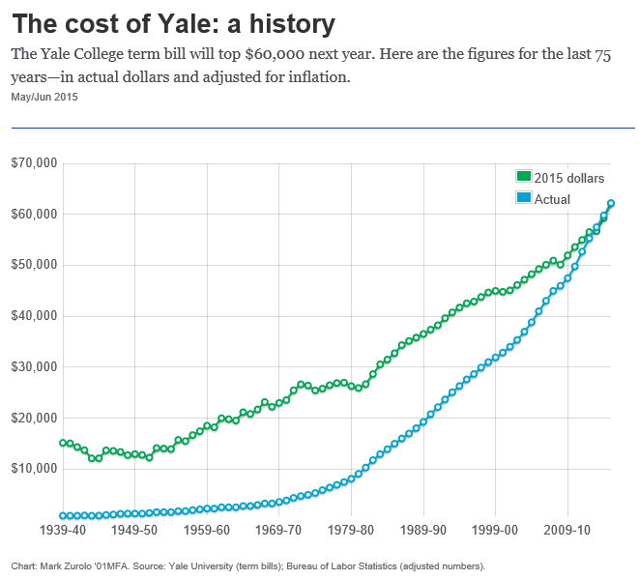

Source: https://yalealumnimagazine.com/articles/4074-the-cost-of-yale-a-history

I used Yale above rather than the University of Alabama simply because I could not find published costs to attend the University of Alabama in 1940. I can assure you it was less than the cost to attend Yale.

If you want to see the outrageous cost of college dating back to 1976 through 2017 simply go here and look at the tables shown.

From a financial point of view there are basically three ways to pay for college.

- Use your own money (this means parent and/or student),
- Gifts and scholarships (or grants) from others, and
- Borrow the money.

Item #3 - Naturally the cost of borrowing is the highest cost ever.

In 2014, there was approximately $1.3 trillion of outstanding student loan debt in the U.S. that affected 44 million borrowers who had an average outstanding loan balance of $37,172. As of 2018, outstanding student loan debt totals 1.5 trillion.

Source: https://en.wikipedia.org/wiki/Student_debt

Item #2 – gifts and scholarships are available (my youngest daughter Dr. Samantha Nix) proved this to me. However, it takes discipline, dedication and a ton of hard work to find them and apply for them. She spent numerous nights in “chat rooms” on the internet looking for scholarships so she would not have to use mom and dad’s money “to attain something she wanted,” and not something we decided she needed.

Most people should resort to Item #1 (Use your own money) but unfortunately will be stuck with Item #3 (Borrow the money).

If you have a child born this year and you anticipate that child will attend just four years of college (and most degrees are obtained in 5 years) you’d better start planning.

According to the College Board, the average cost of tuition and fees for the 2017–2018 school year was $34,740 at private colleges, $9,970 for state residents at public colleges, and $25,620 for out-of-state residents attending public universities. Remember … this is tuition and fees and has nothing to do with living/housing expenses, meals or clothes and transportation.

If the average cost of an in-state public college is $9,970 and assuming an annual increase of 7% per year, in 18 years the cost of tuition could be as high as $33,697.92 per year. That of course would be for the first year only. Tuition is rising every year … not just to the year the child begins college. Considering four years of college, if the student could make it in four years, the cost could continue as follows at 7% annual increases: $36,056.78 the second year, $38,580.75 the third year and $41,281.41 the fourth year. Total cost then for four years for the in-state student at a public college or university could be as high as $149,616.86 – for one child. What if you have 2 or more?

My wife and I had four children. The first three were born four years apart and the last came 6 years after the third. What a dumb plan that was. If they all chose to go to college I could have been in the position of paying tuition for 12 years back to back … then another four years for the last child. I guess that I was fortunate that not all my children chose to go to college and the one that did managed to do it on her own.

As for an out of state student 18 years from now … here’s what you could be looking at for total and annual costs (assuming again a 7% annual compounded rate of college tuition increases):

Year | Amount
1st Year | $86,593.86
2nd Year | $92,655.44
3rd Year | $99,141.32
4th Year | $106,081.21
Total 4 Years | $384,471.83

So, a child born this year could be looking at spending between $150,000 and $385,000 for a four-year public institution – depending on if they go to an in-state or out-of-state college or university.
If parents were intent on accumulating the money needed the first year of college to fund the entire four years of education, based on these numbers, they would need to accumulate …
- $134,791.68 for the in-state college tuition, and
- $346,375.44 for the out-of-state college tuition.
- Keep in mind we are assuming one child here.
Also, we are talking public schools only. If the child is intent on private or Ivy League you can double the cost.
To do this with monthly savings the parents would need to set aside the following amounts, assuming they could earn 7% per year on their invested dollars:
- $330.38 per month for the in-state tuition, and
- $848.98 per month for the out-of-state tuition.
- Also, taxes were not included in these calculations. If your not smart as your investments make money you will have to pay Uncle Sam.
Needless to say, this could drain most family’s budgets after also trying to provide a roof over the young one’s heads, provide elementary and high school costs as well as feed the little darlings. Not to mention, at the age of 0 to about 16 you have no idea if they are going to go to an in-state or out-of-state institution or a private or public college or university.
Of course, you could depend on a rich Uncle to die and leave you well off. The amount needed lump sum today to provide for four years of college in 18 years would be as follows (again assuming a 7% investment return and not factoring in taxes):
- $39,879.99 for the in-state tuition and
- $102,479.99 for the out-of-state tuition.
Some states still offer what is known as prepaid tuition plans … but many have closed these plans. You can see a list of these plans here. Many states have cancelled or closed these guaranteed plans because the cost of college is skyrocketing out of site (and the states have decided not to be a part of this “pragmatic pricing policy”).
The way the prepaid tuition plan works is as follows:
Prepaid tuition plans let you lock in future tuition rates at in-state public colleges at current prices and are usually guaranteed by the state. You pay for amounts of tuition (years, credits or units) in one lump sum or through installment payments. With only a few exceptions, however, most prepaid tuition plans do not cover other expenses, such as room and board.
It should be noted that the only states remaining that will guarantee these plans (and that guarantee is backed by the full faith and credit of the state) is Virginia, Maryland, Massachusetts, Mississippi, Florida and Washington.
There is another scheme for college savings that also falls under section 529 of the IRS code as does the Prepaid Tuition Plans … and these are the 529 College Savings Plans. All states make these available.
Section 529 College Savings Plans are tax-exempt college savings vehicles with a low impact on need-based financial aid eligibility. Unlike Prepaid Tuition Plans, there is no lock on tuition rates and no guarantee. Investments are subject to market conditions, and the savings may not be sufficient to cover all college costs. However, with this added risk comes the opportunity for potentially earning greater returns. You can read more about these plans here.
The point is: Whether you are saving for college using a 529 tax favored plan or not … you still have to start early to reduce your overall burden of future educational costs.
If you don’t start setting money aside now … the only alternative you and your child may have in the future is Scholarships and Grants or “student loans.” Student loans are not only expensive alternatives … they can also cause more burden than one would imagine.
According to a new article that came out today from The Motley Fool; A Shocking Number of Borrowers Say Student Debt Drove Them to Divorce. The article begins …
College students who rack up piles of debt face certain repercussions later in life. Studies have shown that student loans can seriously hinder retirement savings, and large levels of debt have also prompted countless young adults to put off homeownership. There's even data out there supporting the fact that student debt is bad for your health.
But here's a new reason to be wary of student loans: They could increase your likelihood of getting divorced. In fact, 13% of divorced couples say that student loans were what ended their marriage, according to a new report by Student Loan Hero. If you would like to read more on this I suggest you click here.
Student loans (made readily available by the US Government) are costing so much these days. According to www.Studentloanhero.com, It’s 2018 and Americans are more burdened by student loan debt than ever. In fact, the average student loan debt for Class of 2017 graduates was $39,400*, up six percent from the previous year (and that is not at future costs but rather current costs).
Keep in mind that is for undergraduate only (first four years). Those seeking graduate or professional degrees are strangled by the following.

Combined undergraduate and graduate debt by degree:
- MBA = $42,000 (11% of graduate degrees)
- Master of Education = $50,879 (16%)
- Master of Science = $50,400 (18%)
- Master of Arts = $58,539 (8%)
- Law = $140,616 (4%)
- Medicine and health sciences = $161,772 (5%)
Clearly, as these student loan debt statistics show, the cost of attending college is becoming a growing burden for a huge portion of Americans. For more go here.

One major tip to consider when planning for college!

Make sure the child/children you are sending to college or planning to send to college is/are “college worthy.” I don’t mean this in a bad way; naturally all children are worthy members of society … they are our future. Many children, however, are “forced” to go to college when they really are not college material – especially here in America.
Many times, you will hear that the average college graduate will make double what the average high school graduate will make – and that may be true in some occupations.
For example, according to www.study.com, In 2015, adults with bachelor's degrees took home more than those with high school diplomas. Degree holders earned $48,500 a year, while diploma holders earned $23,900. DO YOU REALLY BELIEVE THAT THE AVERAGE HIGHSCHOOL GRADUATE ONLY EARNS $11.49 PER HOUR? I don’t. Let’s look at some skilled jobs that don’t require even a high school diploma:

Average Skilled Trades hourly pay ranges from approximately $15.88 per hour for Electronics Technician to $40.00 per hour for Project Scheduler. The average Skilled Trades salary ranges from approximately $60,000 per year for Project Manager to $89,000 per year for Pipefitter.
Good sales representatives can also make a good income. Here some examples here:

How Much do Sales Representatives Make?

The median annual salary for a sales representative was $57,140 in 2016, according to the BLS. The best-paid 10 percent made roughly $121,080, while the lowest-paid earned approximately $27,500.
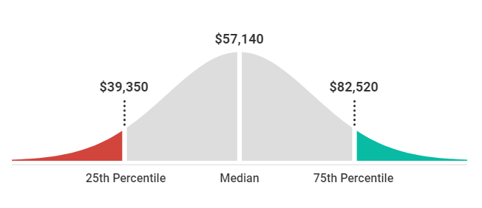
US News and World Report 2

I’m sure that you have heard that if a person is not sure what they should do that perhaps they should focus on technology since it is technology that is on the forefront of American and World progress.
My son-in-law earns a good income as a software engineer … and for that he certainly needed some college. However, sales people in the technology industry do not need a college degree to sell the products of the technology industry. They do need to be smart enough to understand the basics of what they are selling and they must have good people skills … but college degrees should not be a prerequisite.
According to a Forbes article that was written back in 2011 … about companies that pay sales people really well we find this:
There is a lot of money to be made at big tech firms, and not just by executives and developers. Selling their products can make you a small fortune as well.
On average, sales representatives for wholesalers and manufacturers of technical and scientific products make $84,360 in base salary and commission, according to a Bureau of Labor Statistics survey that reflects salary data from May 2010. That’s nearly twice what the average American makes ($44,410) – and it gets even better for some superstar salespeople.
Some of the companies on the list include tech giants Microsoft, Hewlett-Packard and IBM. Sales reps at all three of those companies say they earn over $142,000 a year, on average.
So, when you read stories that a college grad can earn double what a high school grad can earn … take it with a grain of salt. They are talking about the high school grad that has no ambition or direction. Even a long-haul truck driver according to Ziprecruiter.com can earn between $44,500 and $105,000 with the national average being $69,904. And, again, a college degree is not required.
This is not to say that college would not help anyone wanting a career that does not require college … but it is to point out that not all students are actually college material immediately upon graduation from high school.
I personally attended about six months of college at the junior college level before figuring out the even though Uncle Sam was willing to pay for a large chunk of my costs (G. I. Bill) – I was not college material at the time.

Summary

So, when it comes to planning for your child’s education remember these things:
- The cost is going to continue to skyrocket to a point of being unknown and it is not necessarily that the education is getting any better but that salaries of some of the non-essential employees of the colleges are getting out of site; and the colleges and universities have learned the secret of “pragmatic pricing” models (e.g. charging what the market will bear)!
- Start a savings plan early by meeting with a financial advisor that is knowledgeable about college costs and investments that will get you to where you need to be by the time you need to be there. Paying for good financial advise is a whole lot less expensive than going to a banker to borrow the money.
- Begin early conversations and observations with your child/children. Remember they are not all college material regardless of what the education and banking industries would have you believe. Also remember that if you are fortunate you may have more than one child that wants to attend college so your cost could double, triple or even quadruple --- and someday you will still have to retire.
- Finally remember – there will never be “free college for everyone” in America. Contrary to what some want … we live in a capitalistic America and not a socialistic America.
Please feel free to leave your comments below or send me an email if you have any questions to freewavemaker@gmail.com.
Thanks,
Jerry Nix

